Table Of Contents

- Workflow for Creating a New ASM Project..........................................................2
- Alternate Steps for Running the Simulation......................................................10
- Workflow for Split-Model Simulation...............................................................11
- Workflow for Converting the Animation Communication Interface into
Ethernet TCP..................................................................................................14
- Workflow for Doing Lane Change………………………………………………………………19
- Workflow for Handling Traffic Signs and Signals…………………………………………..20

- Workflow for Creating a New ASM Project

- Open the dSPACE AURELION Manager and click on “Create”
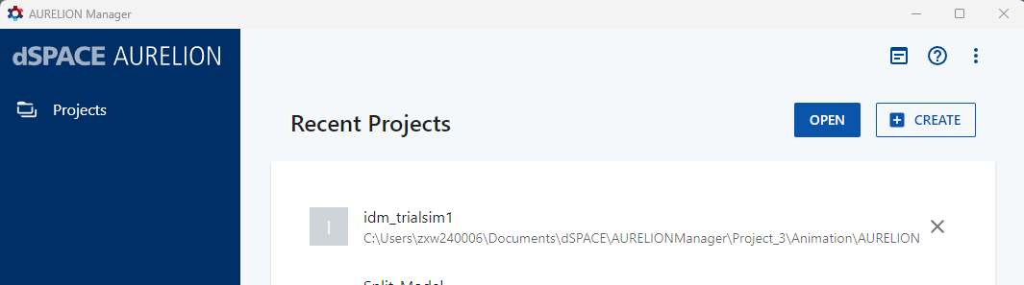
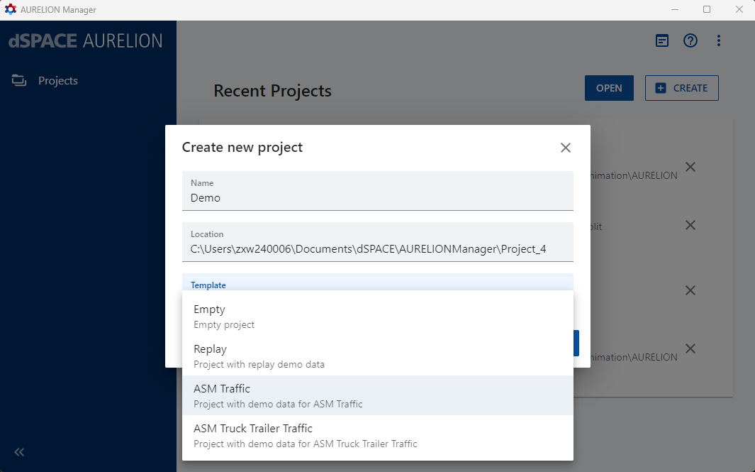

Name the project, select the project location and choose the desired ASM template.

- Go to the Vehicles menu and select the desired ego car.
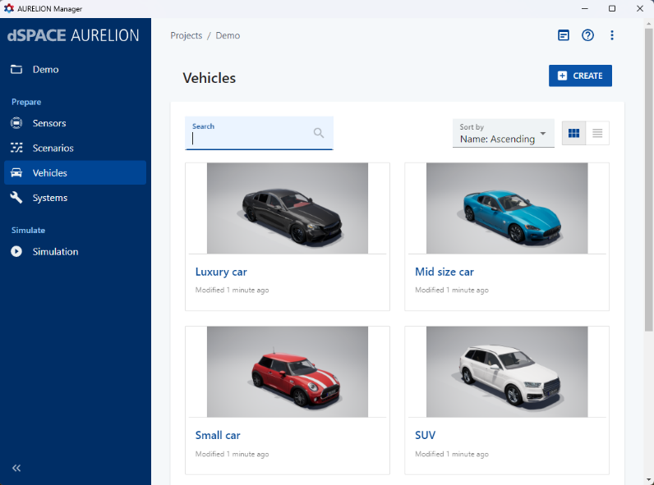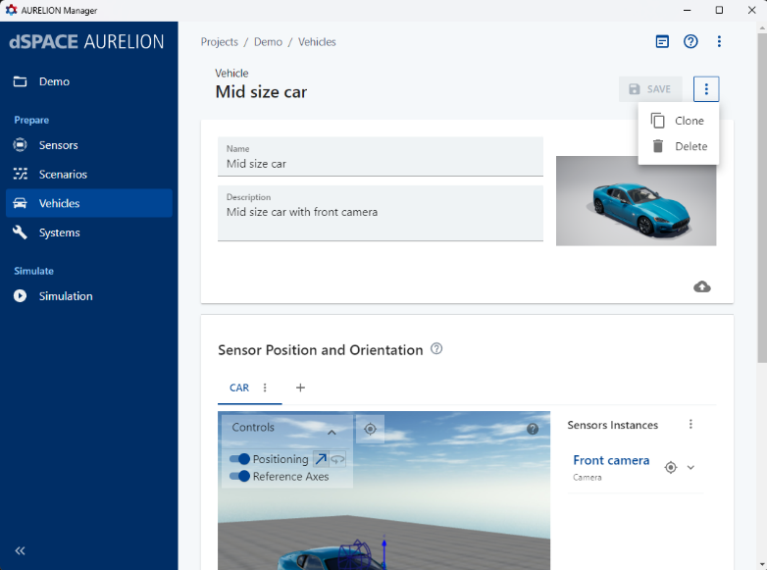
Then create a clone of the vehicle and delete all the sensor instances from the clone. Save the changes made to the clone.

- Then go to the Systems menu and select System.
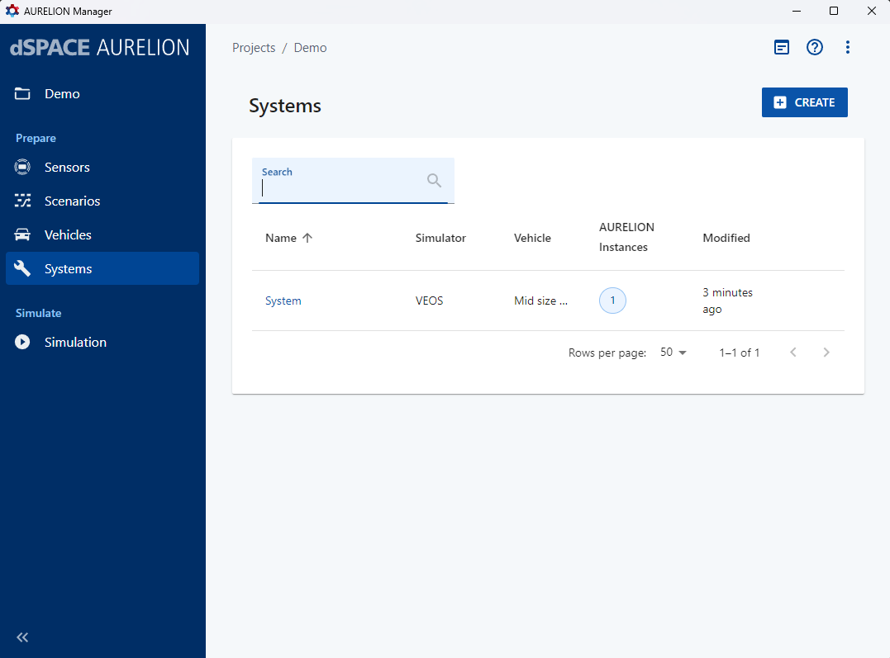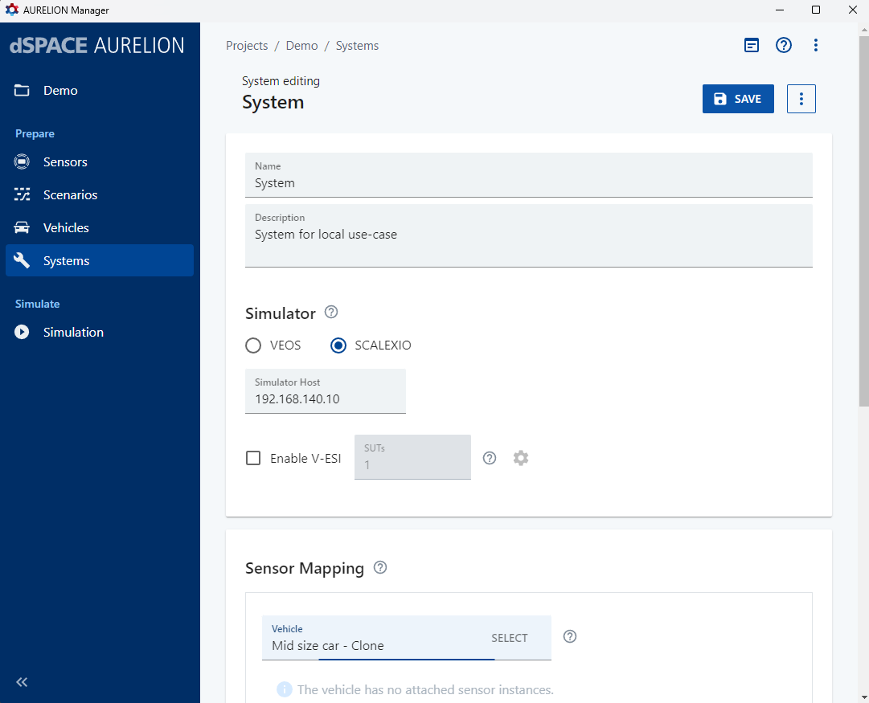
Here, set the Simulator as SCALEXIO, set the Simulator host IP address as 192.168.140.10, and select your cloned vehicle in Sensor Mapping. Save the changes made.

- Go to the Simulation menu.
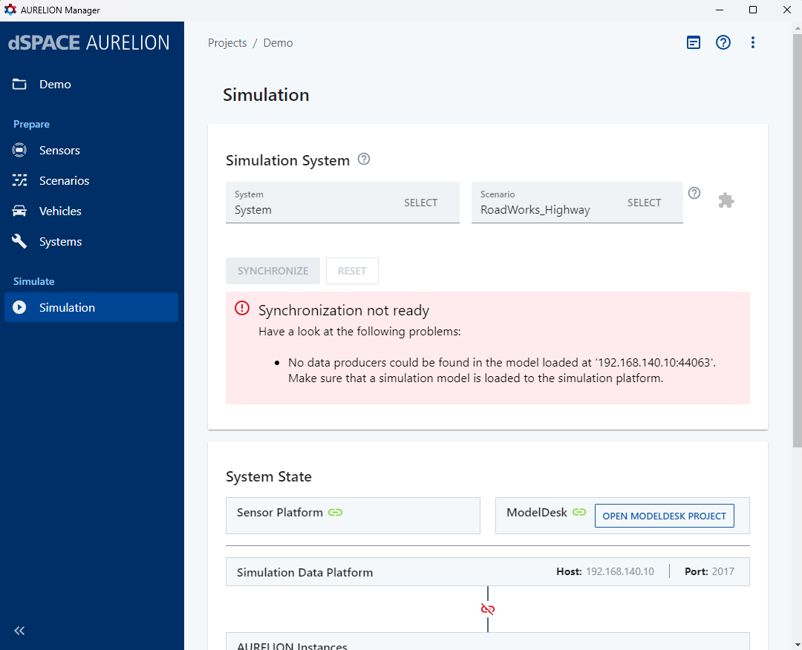

Here, in Scenario, select the animation scenario you wish to run, and then click OPEN MODELDESK PROJECT.

- Go to the Home tab in ModelDesk.
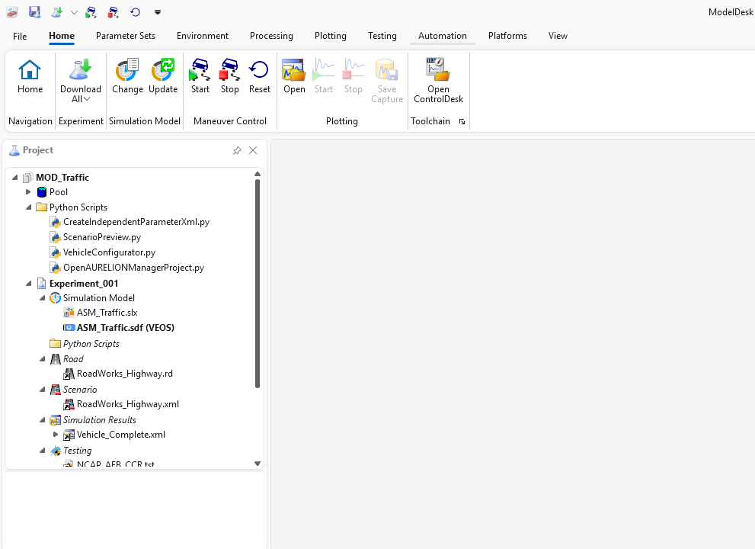
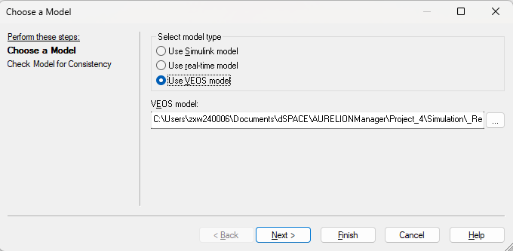
Under Simulation Model, click Change, then select Use Simulink model and click Finish.

- This will open MATLAB, with the working directory set as that of the project's Simulation folder.
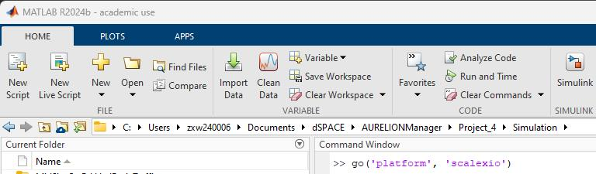

Run the command "go('platform', 'SCALEXIO')" in the MATLAB command window to launch the ASM_Traffic simulink file. Running the go command alone, might change the Communication protocol from Communication Service to Ethernet, causing errors. (Double check the Communication Protocol).

- If needed, make the required changes to the Simulink file and save it. Compile the Simulink file (Ctrl + D) to ensure there are no errors.
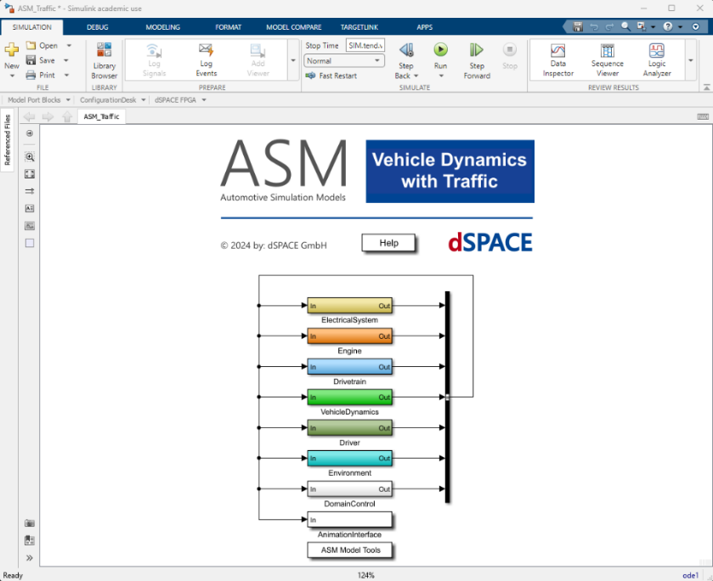

Note: If any errors show up during compilation regarding missing variables that are related to ASM, go to ModelDesk and in the Home tab, under Experiment, click “Download All”. This should also be done if any of the parameters in ModelDesk are changed.

- Go back to ModelDesk.
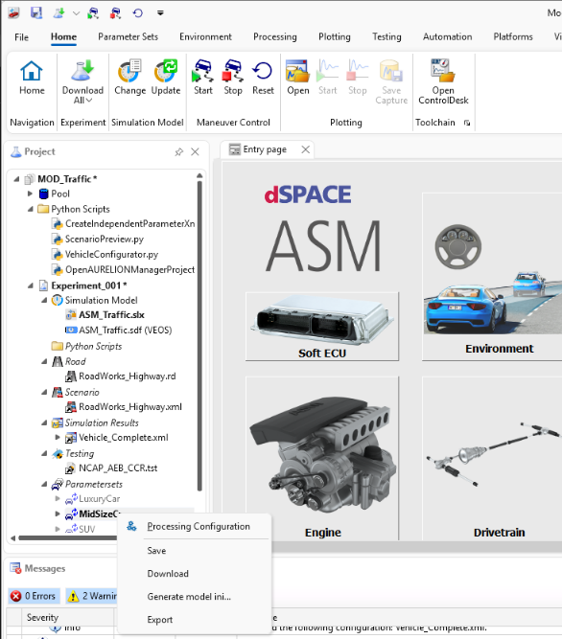

Under Parametersets, right-click the type of vehicle you selected and click "Generate model ini...". In the pop-up file selector, create a new folder in your project directory's Simulation folder, and select it. Then click “Download All”.

- After this, open ConfigurationDesk and click New Project + Application.
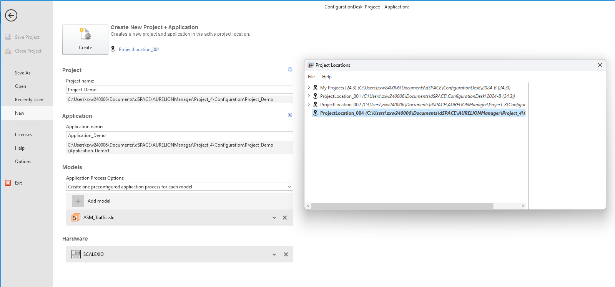
Select your project location (existing or create new) and name your project and application. Under models, select your ASM_Traffic simulink model, under Hardware select SCALEXIO, and then click Create.

- Go to Signal Chain, select ASM_Traffic, and click Analyze.
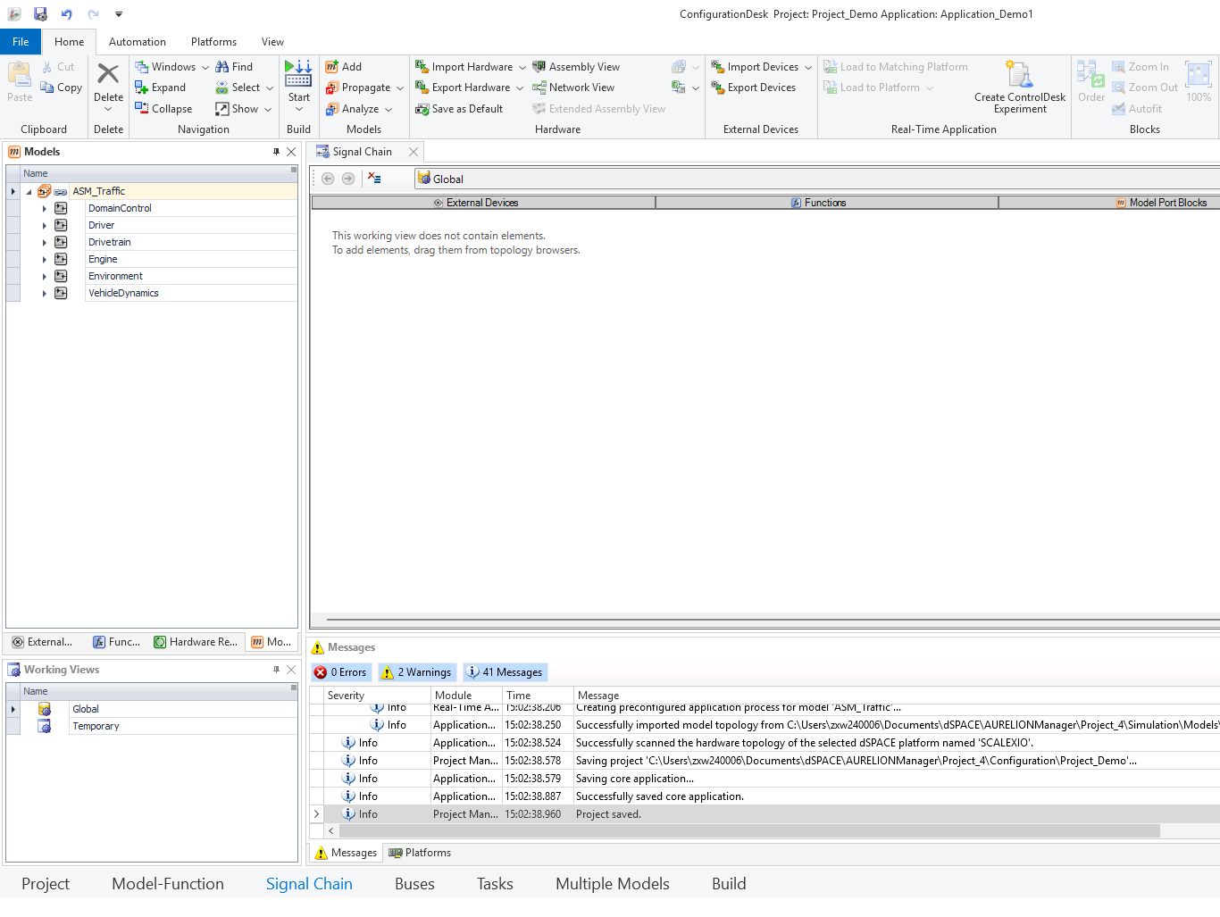

- After analyzing (with no errors), go to Build, then to the Build Configuration tab, select Global Build Settings. This will open the Properties tab on the right. Under Properties, check "Download real-time application after build". You can also uncheck the “Start real-time application” option. Then in the Home tab, under Build, click Start to build the .sdf file used for real-time simulation.
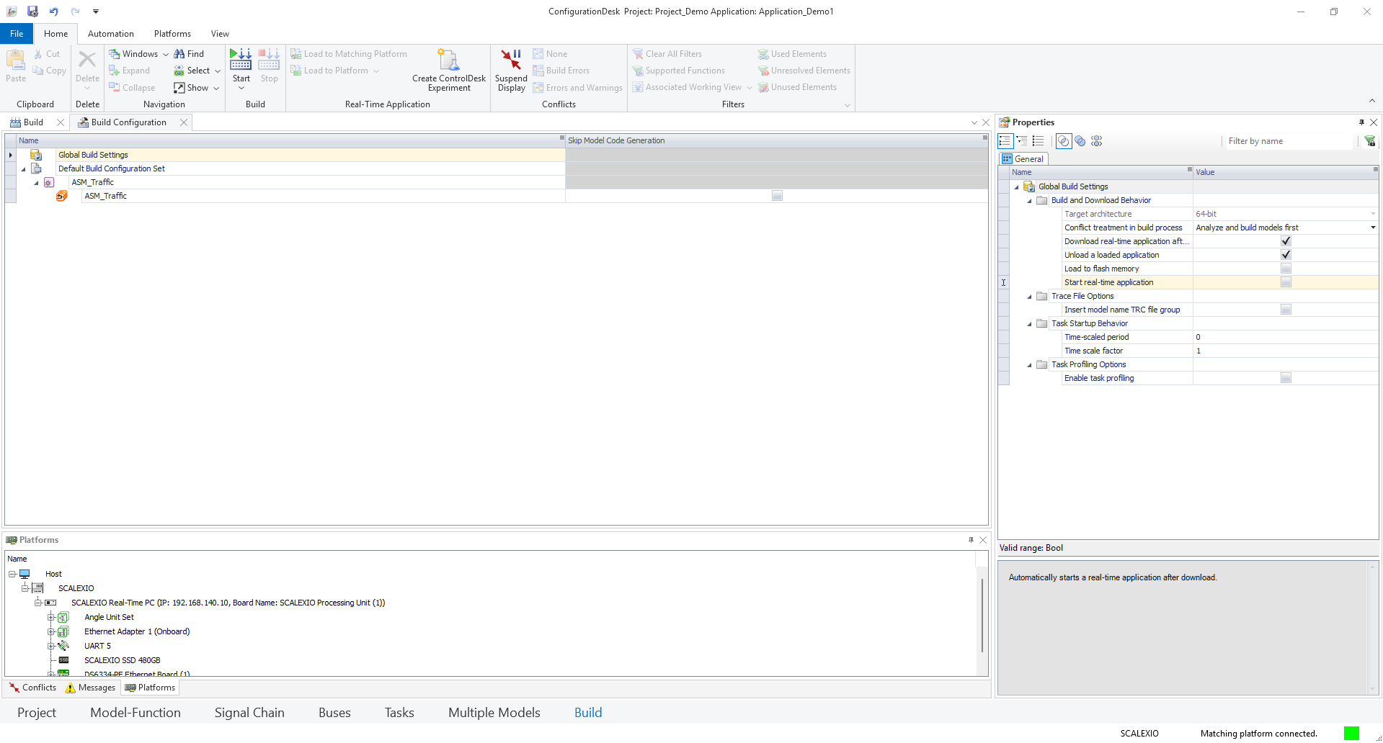
After build completes, the .sdf file should automatically load onto the SCALEXIO. If it doesn't, click "Load to Platform" and then SCALEXIO.

- Go to ModelDesk, under Simulation Model, click Change, select "Use real-time model", give the location of the newly built .sdf file and click Finish.
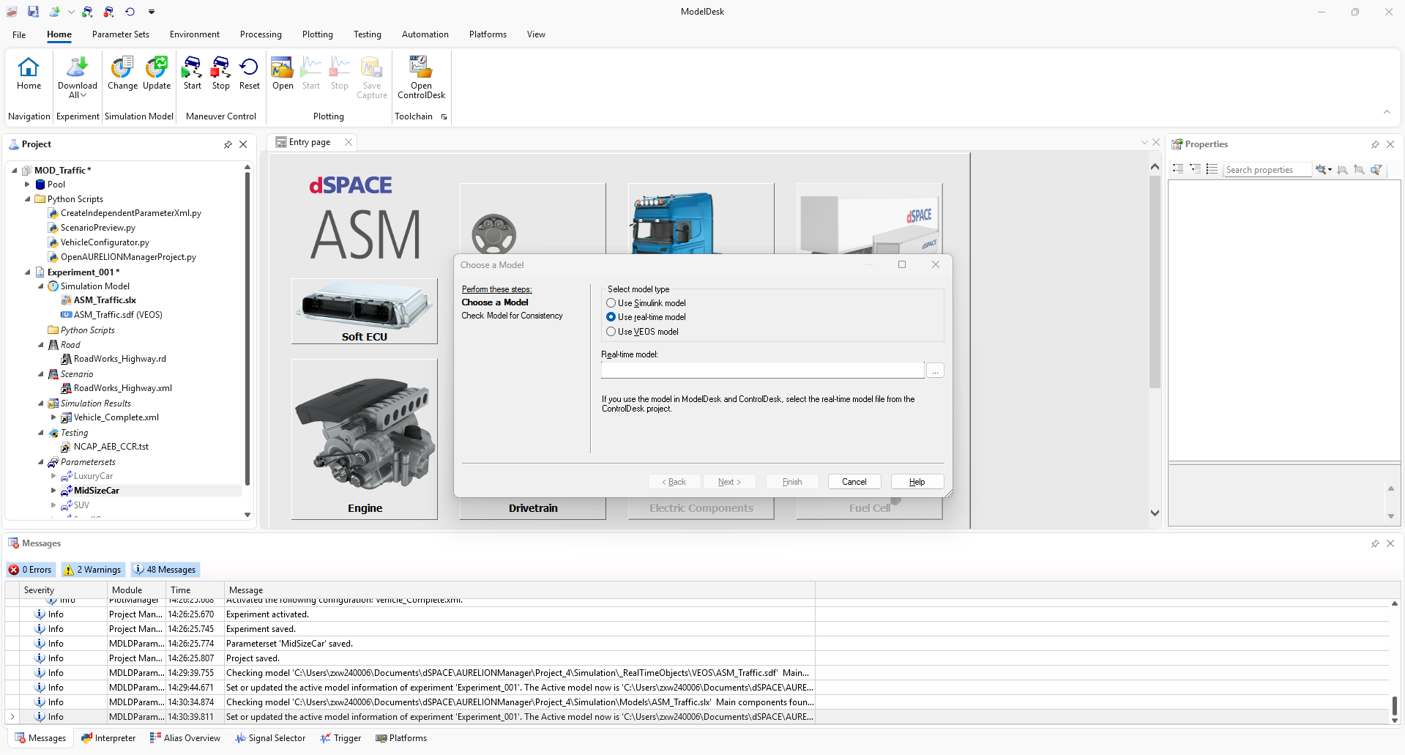
After changing the Simulation Model, click "Download All".

- Then go back to the Aurelion Manager and click Synchronize. This will launch the animation.

- To create a ControlDesk project for measuring values for various variables and scopes in the Simulink model, go to ModelDesk and click ControlDesk. This will automatically create a ControlDesk project that is linked to your current ModelDesk project.

- In the ControlDesk project, go to the Layouting tab and click Insert Layout.
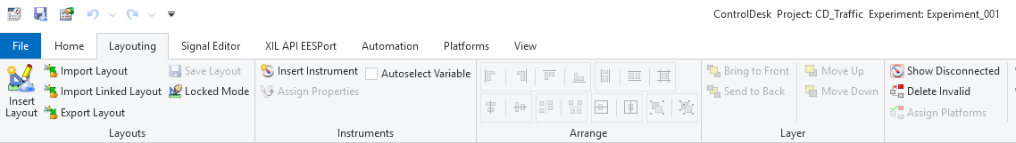

- Then go back to the Home tab and click Go Online.

- In the bottom-left corner, select Variables. Under the .sdf file, go to Model Root to find all the available variables that can be measured, organized in the order of their positions in the Simulink model.
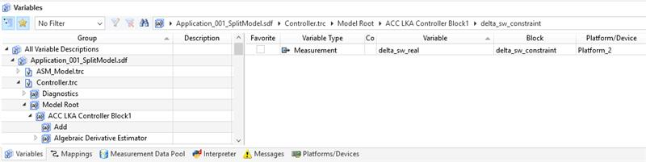

Find and select the parameter you wish to measure. The details of the selected variable will be visible on the right side. Drag the signal from there to the layout and select the type of instrument you wish to use to view the signal.

- To start the simulation, go to ModelDesk and click Start (Under Maneuver Control of Home tab).

- Then, to start measuring the variables, go to ControlDesk and click Start Measuring (in the Home tab).

- To stop the simulation, go to ModelDesk and click Stop (next to Start in previous step). Then click Reset to reset the simulation to its starting point.

- Go back to Control Desk and click Stop Measuring to stop recording the variables.

- Alternate Steps for Running the Simulation
Sometimes when we reset and re-run the simulation, the simulation might behave erroneously (most likely due to some residual values from the previous simulation). This can be solved by using a different workflow for some of the final steps.

- After adding the instruments in the ControlDesk layout, click Go Offline (in the Home tab).
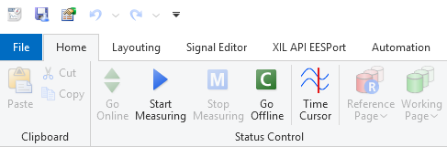

- In the bottom of ControlDesk, go to Platforms/Devices, right-click on the .sdf file and click Unload.
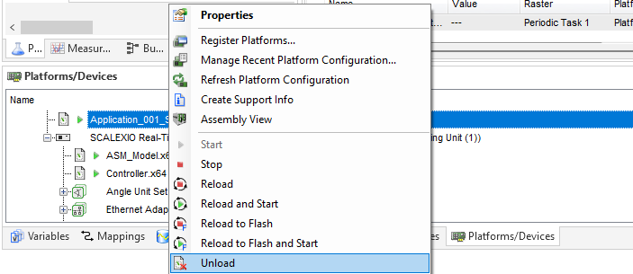

- Then click Start Measuring (in the Home tab). This will load the .sdf file onto SCALEXIO and start the simulation. You can see that the simulation would have started in the Aurelion animation window.
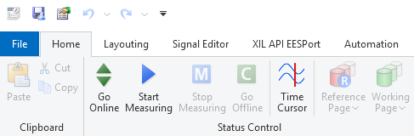

- To stop the simulation, go to ControlDesk and click Go Offline (in the Home tab). Then go to Platforms/Devices in the bottom and unload the .sdf file.

- Workflow for Split-Model Simulation

Due to the large size of the ASM vehicle dynamics model, building the real-time simulation file in ConfigurationDesk will take a considerable amount of time. Therefore, it becomes very difficult to make changes in the Simulink model and then rebuild. We can circumvent this issue by splitting the Simulink model into two separate parts, one containing the vehicle dynamics and the other containing the controller.

- Divide the blocks in the Simulink model into 2 subsystems, as shown below.
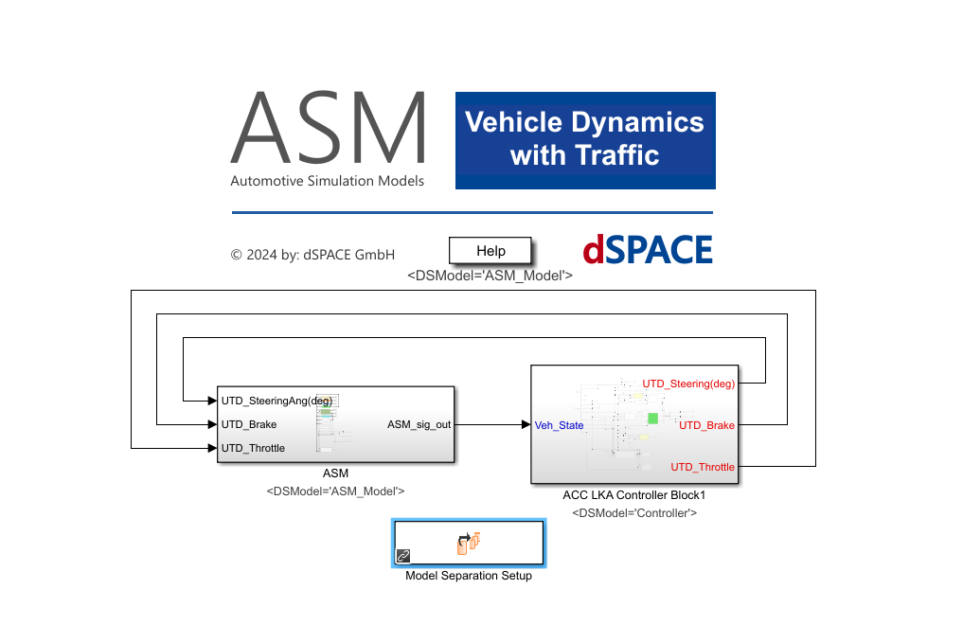

- Then add the “Model Separation Setup” block, shown above, from the Simulink Library Browser. Double click the block to open the model separation setup window.

- The left-hand section shows the unassigned subsystems in the Simulink models. You have to create as many models as you need in the right-hand section, using the “Add model” button (first one in the middle). Then, the available subsystems in the left side can be assigned to the target models in the right side. Select the available subsystem and its target model and then click the “Assign subsystem” button (blue arrow). This will move the selected subsystem from the left side to the corresponding model in the right side. After assigning all the available subsystems, click Save and then Create Models.
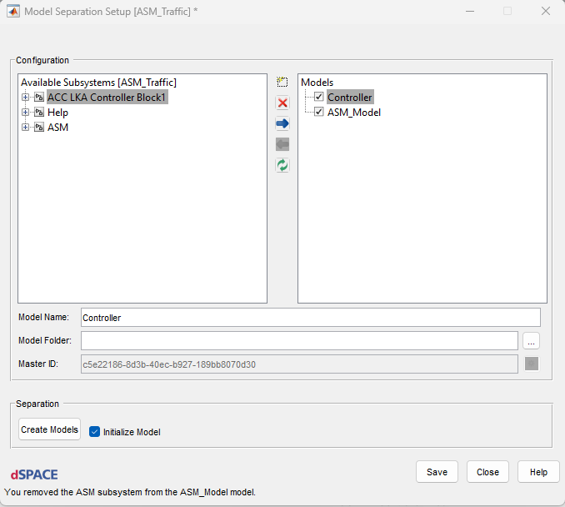

- After model separation is completed, a separate Simulink file will have been created for each target model defined, along with a .mcd file. These files will be created in the MATLAB working directory.

- Open ConfigurationDesk and create a new project as mentioned above. However, select the .mcd file created by model separation as the model, instead of selecting a Simulink file.

- You will find that all your target models created have been loaded in Signal Chain. Analyze each model separately to ensure that there are no errors. Then build the real-time simulation file, as mentioned above. (For the first build, you will have to build all the models.)

- After the build completes, go to your active ModelDesk project. Change the Simulation Model to “Use real-time model” and change the file path to that of the .sdf file you just built.

- Then, do a “Download All” and all the subsequent steps required to run the simulation, as mentioned above.

- When you need to make a change, say in the controller part, go to the original unsplit Simulink model with the model separation setup block (ASM_Traffic). Make the changes in the required controller subsystem. DO NOT make changes in the separated Simulink models that were previously generated.

- After making your changes, save the Simulink file. Then open the model separation setup block and click Create Models. This will recreate the separated Simulink files and the .mcd file.

- Then, go to the ConfigurationDesk project and Analyze the models that were changed.

- After analyzing, go to Build, and then the Build Configuration tab.
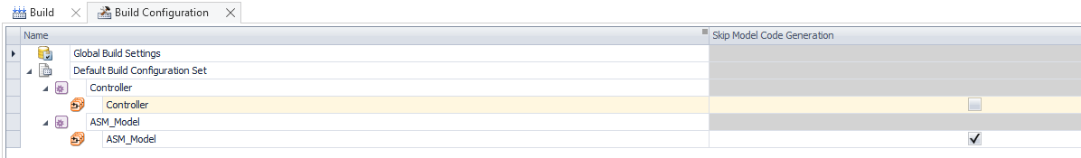
Here, check the Skip Model Code Generation checkboxes for all the models that were unmodified. Then build the real-time simulation model file.

- After the build completes, go to ModelDesk and update the real-time simulation model file (Home → Simulation Model → Update).

- Then do a “Download All”, synchronize in Aurelion Manager, and perform all the subsequent steps required to run the simulation, as mentioned above.

- Workflow for Converting the Animation Communication Interface into Ethernet TCP

By default, the communication method used by Aurelion Animation is the Communication Service protocol. This uses the existing Ethernet connection between the PC and SCALEXIO to send the animation data, along with other simulation-related data. Sometimes, the Communication Service protocol fails to produce the animation, even though the simulation project is running properly and data is obtained, say in ControlDesk. This issue can be solved by connecting an additional Ethernet cable between the PC and the SCALEXIO and then configuring the animation to communicate through this Ethernet cable using the TCP protocol. The steps to reconfigure an existing project to communicate via Ethernet are given below.
- Open the ConfigurationDesk project and go to Signal Chain → Functions (left-side middle). Right-click in the blank white space and click “Clear All Filters”.
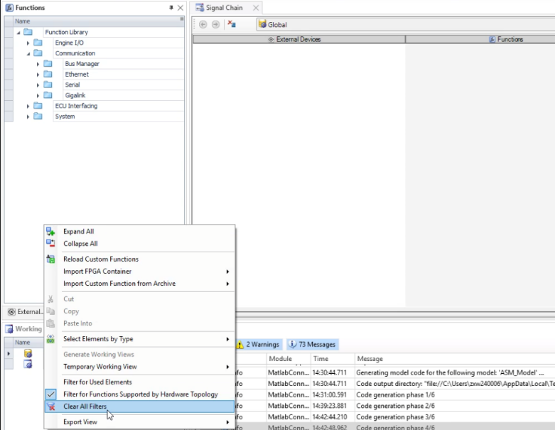

- In Functions, expand Function Library → Communication → Ethernet. Drag and drop “Ethernet Setup” and “TCP” into the middle window.
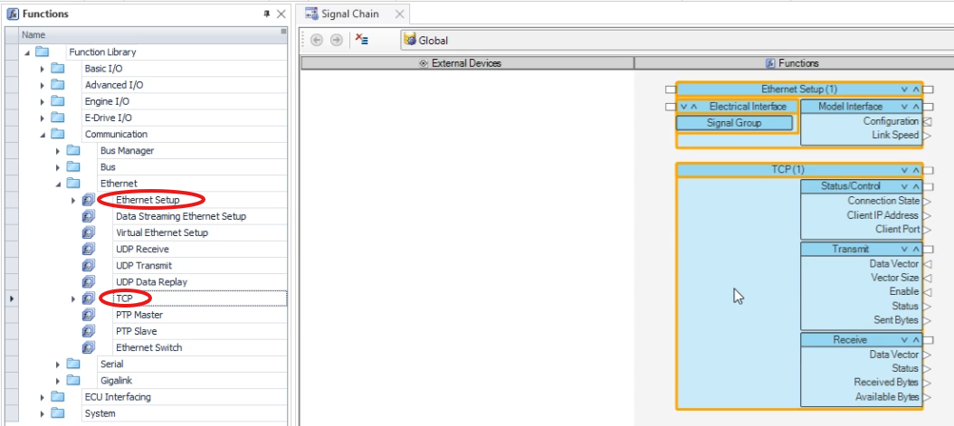

- Select the dropped “Ethernet Setup” block, then in the right-side Properties window, go to Electrical Interface, expand Hardware Assignment. Select Assigned Channel as “SCALEXIO Processing Unit” (the first option) and Ethernet Controller as the port on the SCALEXIO where the additional cable is connected.
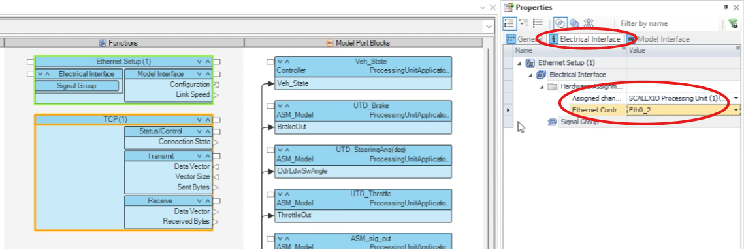

- Then go to the General tab. Set an IP address. It can have any port except 0, 1, 10, 11, 255. (Here we used 192.168.140.30)
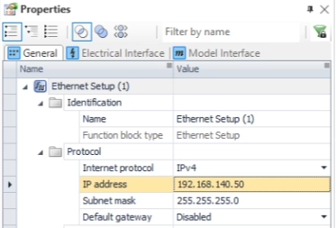

- On the left side, go to the Models tab (in line with Functions). Drag and drop “AnimationInterface” into the middle window.
[If AnimationInterface is not shown, go to the Simulink model → AnimationInterface → ANIMATION_INTERFACE → Configure Connection Settings, change Communication Method to Ethernet TCP and Simulation mode to “1” (HIL).]
[While running the “go” command during launch, running “go(‘platform’, ‘SCALEXIO’)” will automatically set the Communication Method as Communication Service, whereas running it simply as “go” will set it as Ethernet TCP, but the Simulation mode will be “0” (SIL).]
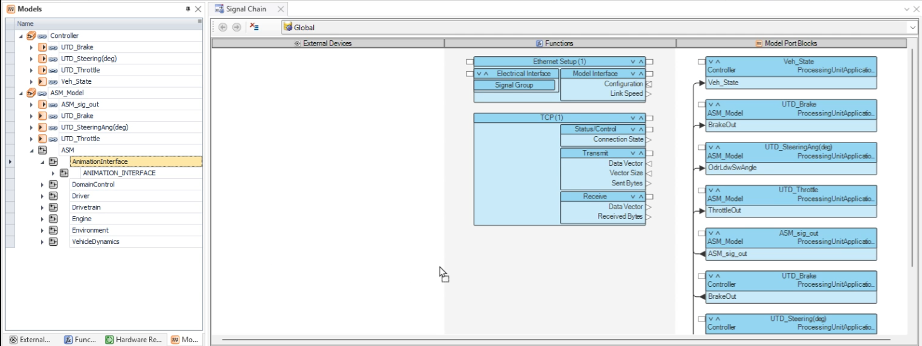

- Connect all the ports of the AnimationInterface blocks (right side) with the corresponding ports of the TCP block. All the ports of the AnimationInterface blocks must be connected.

- Then select the “Status/Control” block within the TCP block. In Properties, under Client IP Address → Behavior Model → Model Access, switch it to Disabled.
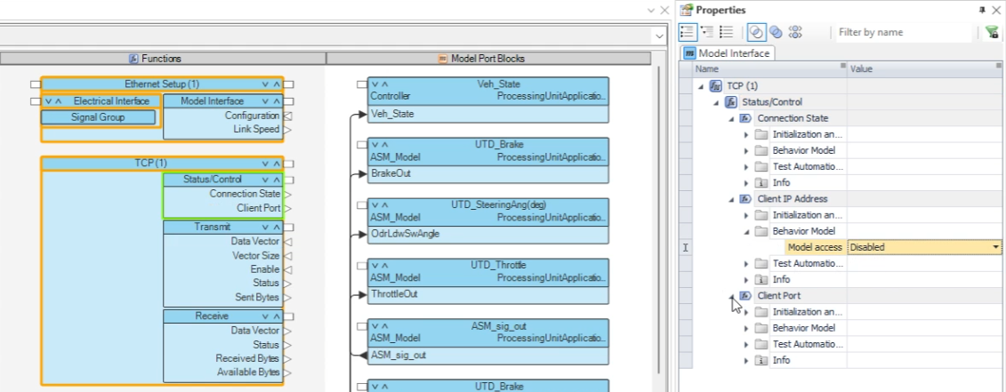

- Similarly disable the Client Port, as well as all the unused ports on the Transmit and Receive blocks.

- Go to the Transmit block Properties → Enable → Test Automation Support → Activate…, and switch it to Enabled. Make “initial switch setting” as Substitute value.
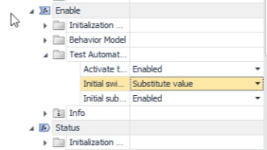

- Under Transmit → Max. vector size, set it as 65507. Then select the Receive block and set its Max. vector size also as 65507. [This is to resolve the size mismatches (the yellow lines).]
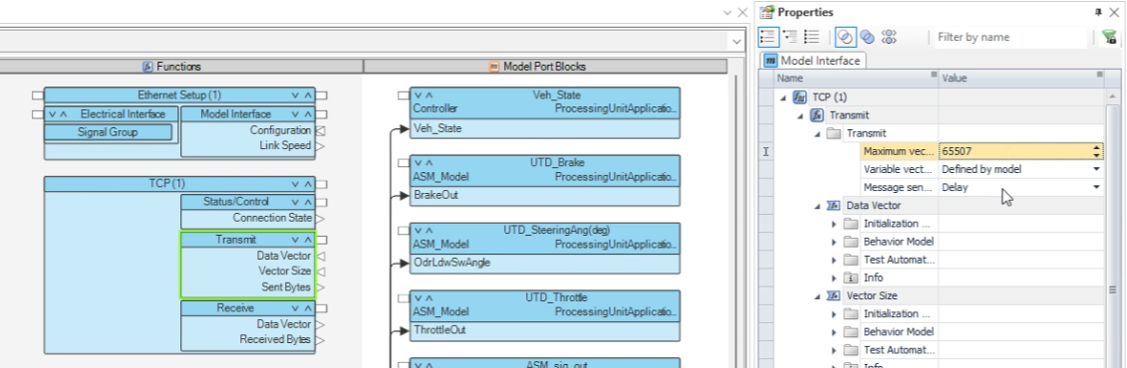

- Click the “TCP (1)” block. Then go to Properties → General → Referencing Configuration → TCP on Ethernet, and select from the drop down (should be the IP address we gave earlier). Also assign TCP → Local port as 2017. [The “TCP (1)” block should no longer be orange.]
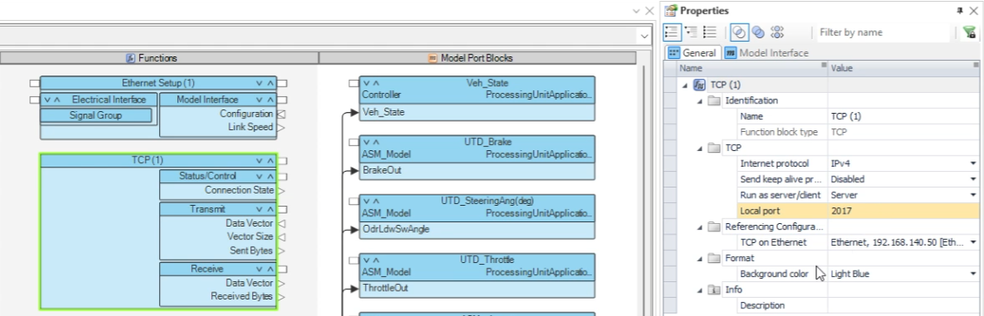

- Then go to Build → Build Configuration → Global Build Settings. In its Properties, check the Download real-time application after build box. Then Start Build.

- While the build is going on, type “View Network Connections” in Windows search bar. Here, double click the SCALEXIO Ethernet Connection, Properties → click “Internet Protocol Version 4 (TCP/IPv4) → Properties → Advanced → Add. Here, add the IP address “192.168.141.12”. The Subnet mask field should automatically populate itself. Click Add and then close all the windows.

- After the build completes, go to ModelDesk, change Simulation Model to the .sdf file and click Download All.

- Then go to File Explorer → [Project Folder] → Animation → AURELION → project.json. In this file, set “comStackVersion” as 0, and save the file.

- Then close and reopen Aurelion Manager. Set the Simulator Host IP address as the same IP address set earlier (192.168.140.30).

Workflow for Doing Lane Change
In ModelDesk, we can change/modify the Maneuver under any Scenario. Click on the Ego Vehicle’s Maneuver Block. The right side of the window shows different settings. Click on Lane index type to see the available options.
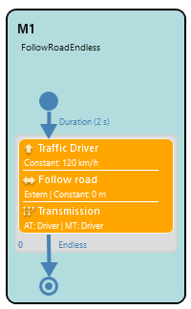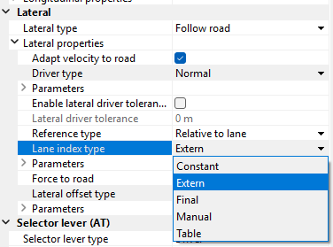
In ASM, the lane index value is 0 on a single lane. For two lanes, the right most lane is indexed 0. For three lanes, the center lane is indexed 0. Using the Lane index type, we can play with the lane change settings accordingly. The option of Extern allows to change the lane by changing the index in the following manner. +1 for changing one lane on the left side; -1 for changing one lane on the right side. The option of Force to road keeps the vehicle on the road. However, if it is not checked then the vehicle may go offroad accordingly.
The root of the Lane index in the Simulink is as follows.
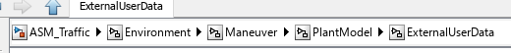
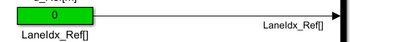
We can change it in the ControlDesk also by accessing the same variable through Model Root.
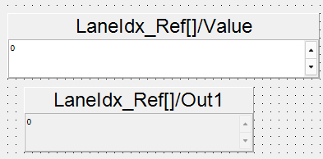

Workflow for Handling Traffic Signs and Signals
In ModelDesk, we can change/modify the scenario and the route. On the selected route, we can add/delete any object. It could be a traffic post, traffic sign, traffic light etc. The useful signals in the respective Simulink file are as follows:
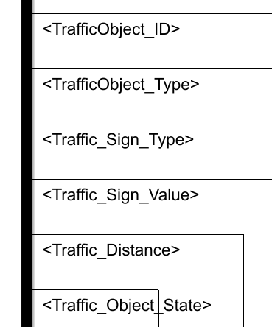

These signals can be used to get data of traffic objects on the road. The vehicle can get this information from 130 meters distance. Regarding Traffic Lights, each traffic light has its own data stream.
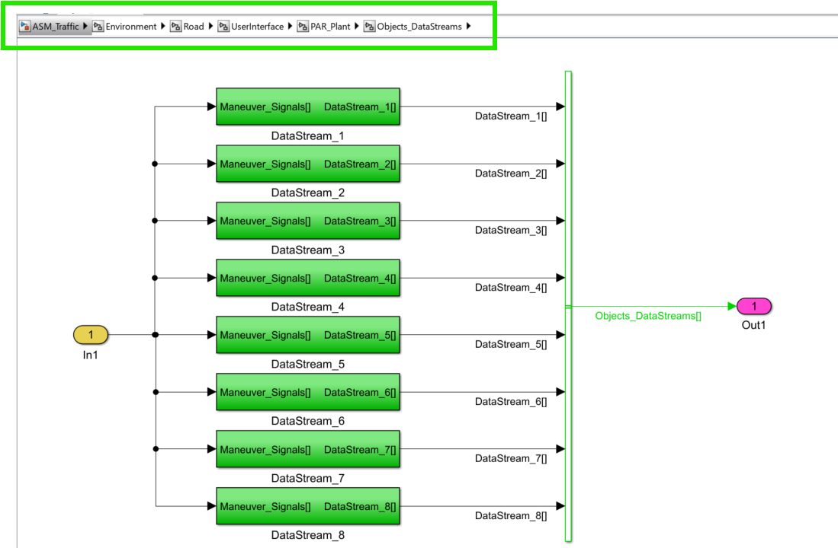
Out of these 8, the first four are defined with default values in
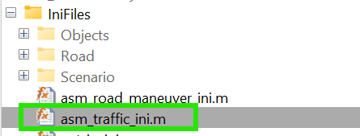
The corresponding values define signal phase and timing, and is same for the same data stream. For example, [0 1..] corresponding to [1 1…] turns signal to 1 (red) at time t = 0 sec, and then keeps it 1 (red) till time t = 1 sec.

In the root directory given above, the selected DataStream can be controlled by the signal (Sw_DataStream_x). The value 0 means we are controlling the traffic light under DataStream x; the value 1 means the traffic light is following the asm_traffic_ini.m for its signal phase and timing.
TrafficObject_Type is the subclass of TrafficObject_ID.
Traffic_Sign_Type is also the subclass of TrafficObject_ID.
Traffic_Sign_Value is the subclass of Traffic_Sign_Type .

